Donor Project Visit to Sumatra October 2018
Itinerary
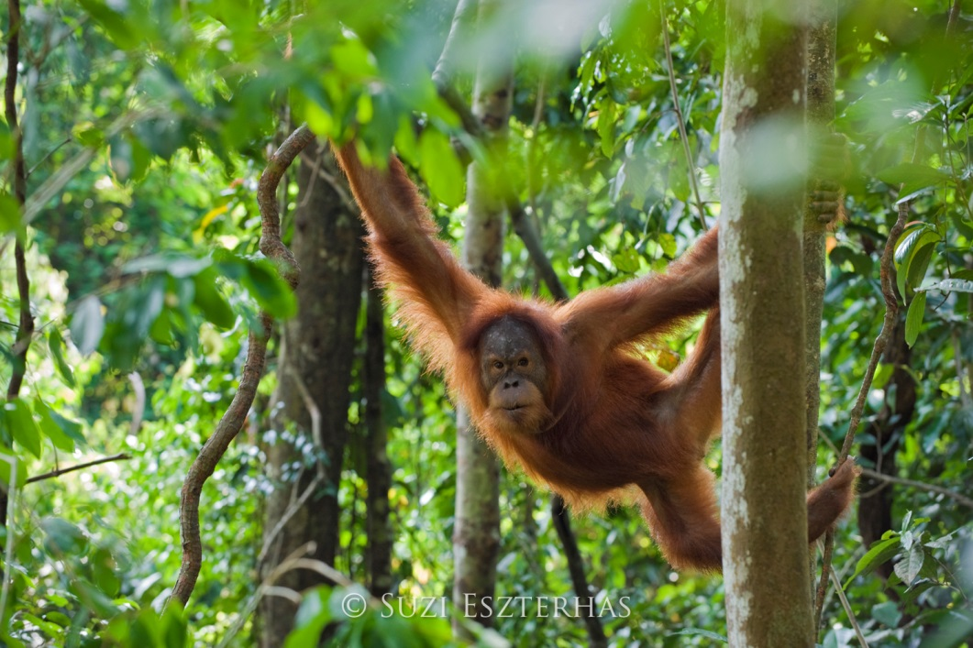

Date | Where | What
Saturday 29th September | London | Depart London Heathrow 22.05
Sunday 30th September | Medan | Arrive Medan 19.05 | Grandhika Hotel, Medan
Monday 1st October | Medan | Rest, welcome at OIC office | Grandhika Hotel, Medan
Tuesday 2nd October | Medan - Bukit Mas | Drive to Bukit Mas, visit permaculture demonstration site | Family homestay
Wednesday 3rd October | Bukit Mas - Halaban - Bukit Lawang | Plant trees in forest restoration site, Travel to Halaban to visit more established restoration site to see what a difference a few years makes. Drive to Bukit Lawang | Ecolodge, Bukit Lawang
Thursday 4th October | Bukit Lawang | Forest trekking to see wildlife in natural habitat | Camp in forest
Friday 5th October | Bukit Lawang | Forest trekking, waterfalls, river tubing | Ecolodge, Bukit Lawang
Saturday 6th October | Flyover | Leuser flyover | Grandhika Hotel, Medan
Sunday 7th October | Fly home or optional 3 day R&R extension | Fly to Pulau Weh | tbc
Monday Oct 8th | Pulau Weh | Rest day in Pulau weh
Tuesday Oct 9th | Pulau Weh - Medan-London | Fly to Medan - onward flight to London
Wed Oct 10th | Arrive London am | Arrive London 5.55 am

